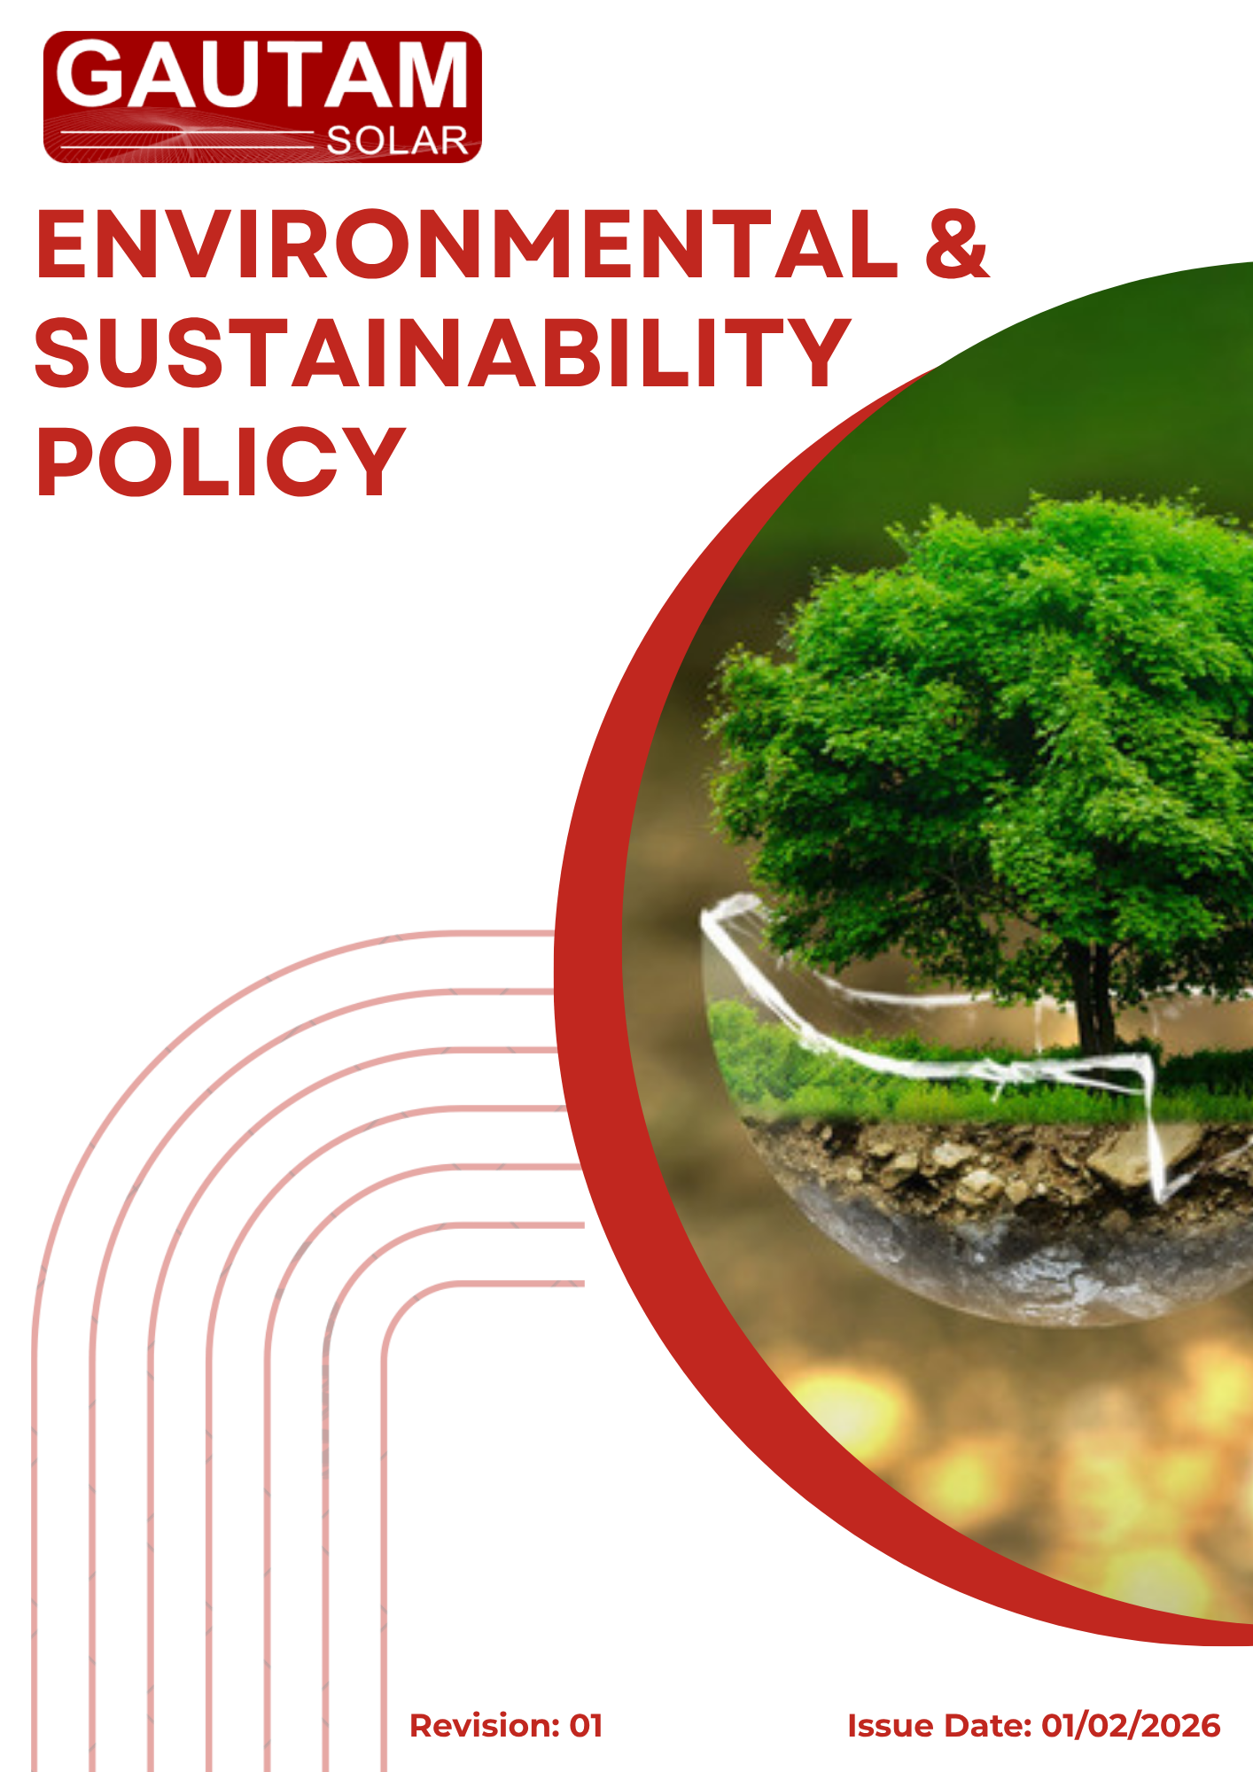

Contents
❖ Introduction 3
❖ Scope 3
❖ Policy Commitments 4
❖ Quantitative Environmental Targets 6
❖ Implementation Responsibility 7
❖ Monitoring and Review Mechanism 9
❖ Employee / Stakeholder Acknowledgment 10

- Introduction
Gautam Solar Private Limited is committed to conducting its operations in an environmentally responsible and sustainable manner. As a leading organization in the solar energy sector, the Company recognizes its responsibility to minimize environmental impacts while contributing to the global transition towards clean energy.
The Company aligns its environmental strategy with internationally recognized frameworks such as the Global Reporting Initiative (GRI) Standards and the United Nations Sustainable Development Goals (SDGs), ensuring transparency, accountability, and continuous improvement in sustainability performance.
- Scope
This Environmental & Sustainability Policy is applicable across all Gautam Solar Private Limited employees, workers, contractors, sub-contractors, suppliers, and other stakeholders globally, including the communities in which Gautam Solar Private Limited operates. It ensures that environmental standards are consistently maintained throughout all its sites, operations, and business relationships.
Site | Location
Registered Office | D-120, Okhla Industrial Area, Phase-1, New Delhi-110020, India
Factory Unit 1 | Plot 67-70, Sec-8A, SIDCUL, Haridwar, Uttarakhand- 249403, India
Factory Unit 2 | 7 KM Milestone, Tosham Road, Bhiwani, Haryana-127032, India

- Policy Commitments
Gautam Solar Private Limited is committed to the following:
Sustainability Area | Commitment | Aligned SDGs
Energy & GHG Emissions | - Improve energy efficiency and increase renewable energy adoption  - Increase the share of renewable energy in total energy consumption  - Monitor and manage greenhouse gas emissions across Scope 1 and Scope 2, Scope 3 | SDG 7, 13
Water Management | - Promote responsible water usage, conservation, and reuse  - Monitor water consumption and discharge to ensure compliance  - Reduce dependency on freshwater sources through alternative solutions | SDG 6
Materials, Chemicals & Waste | - Minimize waste and ensure safe handling of materials and chemicals  - Promote recycling and reuse of materials wherever feasible  - Reduce the use of hazardous substances in operations and products | SDG 12
Product Use | - Enhance product efficiency and reduce lifecycle impacts  - Provide guidance to customers on efficient and safe product usage  - Continuously innovate to enhance product sustainability performance | SDG 7, 12
Product End-of-Life | - Promote recyclability and circular economy practices  - Integrate circular economy principles into product design  - Reduce environmental impact associated with product disposal | SDG 12
Customer Health & Safety | - Ensure product safety and compliance  - Monitor and address product-related safety incidents  - Continuously improve product safety and quality standards | SDG 3
Compliance | - Adhere to environmental laws and regulations  - Establish internal controls to manage environmental risks  - Promote ethical and transparent environmental practices | SDG 16
Continuous Improvement | - Monitor and enhance environmental performance  - Encourage employee participation in sustainability initiatives  - Continuously enhance environmental management systems and practices | SDG 9, 13
- Quantitative Environmental Targets
(Baseline Year: FY 2023-24 | Target Year: FY 2030-31)
Consolidated Environmental Targets
Sustainability Area | Indicator | Target by FY 2030-31 | Aligned SDGs
Energy & GHG Emissions | Scope 1 & 2,3 GHG Emission | 20% reduction | SDG 13
Energy & GHG Emissions | Renewable Energy Share | 50% of total energy consumption | SDG 7
Energy & GHG Emissions | Energy Efficiency | 15% improvement per unit production | SDG 7
Water Management | Water Consumption Intensity | 25% reduction | SDG 6
Water Management | Water Recycling & Reuse | Minimum 30% reuse across operations | SDG 6
Water Management | Rainwater Harvesting Coverage | 100% manufacturing sites | SDG 6
Materials, Chemicals & Waste | Waste Diversion from Landfill | 90% of total waste | SDG 12
Materials, Chemicals & Waste | Hazardous Waste Reduction | 20% reduction | SDG 12
Materials, Chemicals & Waste | Sustainable Packaging | 75% recycled/eco-friendly materials | SDG 12
Materials, Chemicals & Waste | Chemical Compliance | 100% compliance with applicable standards | SDG 12
Product Use | Solar Module Efficiency | 10% improvement | SDG 7
Product Use | Product Lifecycle Carbon Footprint | 15% reduction | SDG 13
Product Use | Product Safety Compliance | 100% compliance | SDG 3
Product End-of-Life | Product Recyclability | 85% of solar modules | SDG 12
Product End-of-Life | Responsible Disposal | 100% via authorized recyclers | SDG 12
Product End-of-Life | Take-Back Program | Fully implemented | SDG 12
Customer Health & Safety | Critical Safety Incidents | Zero incidents annually | SDG 3
Customer Health & Safety | Product Risk Assessments | 100% annual coverage | SDG 3
Customer Health & Safety | Safety Communication | 100% labeled products | SDG 3

- Implementation Responsibility
The implementation, monitoring, and continual improvement of this policy shall be a shared responsibility across all levels of Gautam Solar Private Limited.
(Environment, Health & Safety EHS) Head
The EHS Head shall have overall responsibility for the implementation and review of this policy and shall:
- Ensure alignment of operations with policy commitments and environmental objectives
- Monitor and track performance against defined targets and GRI indicators
- Conduct periodic environmental reviews, audits, and assessments
- Coordinate with cross-functional teams for effective implementation
- Report environmental performance to top management
Top Management
Top Management shall:
- Provide strategic direction and resources for effective implementation of this policy
- Approve environmental objectives, targets, and improvement plans
- Ensure integration of sustainability into business strategy and decision-making
Department Heads / Functional Managers
Department Heads shall:
- Integrate environmental requirements into departmental operations
- Ensure compliance with applicable environmental regulations and internal procedures
- Support data collection and reporting for environmental performance
- Promote resource efficiency and waste reduction within their respective functions
Employees and Workers
All employees and workers shall:
- Comply with the requirements of this Environmental & Sustainability Policy
- Follow all applicable environmental procedures, controls, and safety practices
- Use resources such as energy, water, and materials responsibly
- Report any environmental incidents, risks, or non-compliances to the concerned authority
- Participate in environmental awareness and training programs
Contractors and Suppliers
All contractors, sub-contractors, and suppliers shall:
- Adhere to the environmental requirements outlined in this policy and applicable contractual obligations
- Comply with relevant environmental laws and standards
- Minimize environmental impacts associated with their activities, products, and services
- Support Gautam Solar in achieving its sustainability objectives

- Monitoring and Review Mechanism
The Company shall monitor progress against defined targets through internal assessments, performance tracking, and audits.
This policy and its associated targets shall be reviewed annually by the EHS Head and top management to ensure:
- Continued relevance
- Alignment with regulatory requirements
- Achievement of environmental objectives
- Identification of improvement opportunities
Corrective and preventive actions shall be implemented wherever required.

Approved By:

Designation:

Last Review Date: 01/02/2026 Next Review Date: 01/02/2027

- Employee / Stakeholder Acknowledgment
I hereby acknowledge that I have received, read, and understood the Environmental & Sustainability Policy of Gautam Solar Private Limited.
I understand my responsibility to comply with the requirements outlined in this policy and to support the Company’s environmental objectives, commitments, and sustainability targets.
I agree to:
- Follow all applicable environmental procedures, controls, and guidelines
- Use resources such as energy, water, and materials responsibly
- Report any environmental incidents, risks, or non-compliance to the concerned authority
- Participate in environmental training and awareness programs as required
I understand that failure to comply with this policy may result in appropriate corrective or disciplinary actions in accordance with company procedures.
Employee ID
Department
Designation
Location
Signature
Date

